Automation of AC Inductive Switching Characterization Data Acquisition using LabVIEW Software
Nurul Afiqah Mohd Hasbullah¹ , Aik Wan Chan¹, Jingle Navarra²
¹SBN Characterization Laboratory Onsemi, Seremban, Malaysia
²APG HV NPD Onsemi, Seremban, Malaysia
NurulAfiqah.MohdHasbullah@onsemi.com; AikWan.Chan@onsemi.com; Jingle.Navarra@onsemi.com

Abstract—Inductive switching test is one of the critical characteristics for power discrete semiconductor devices such as IGBT. The measured values for each parameter such as Ton, tr, Toff, tf, Eoff, and Eon, must be accurate to meet the device actual characterization and performance per the customer’s requirement. Typically, the AC inductive switching characterization is done in the characterization laboratory using a dedicated bench test setup consists of switching test circuit, power supply, gate driver, arbitrary pulse generator and oscilloscope. This is done manually, and the data is collected based on the oscilloscope turn on and turn off generated waveforms. Using this method, it will take about two weeks to complete a request depending on the number of switching test condition. The technician needs to zoom in the turn on/off waveforms to be able to record the measured value. This method is labor intensive and prone to human error, which may result in inaccurate measurement. To improve the data acquisition method, an application program using LabVIEW software was developed to automate the AC inductive switching characterization data collection. This program will automatically capture the full double pulse waveform on oscilloscope, rebuild the captured oscilloscope waveform into the program’s waveform graph, applied the Median filter on the source voltage and current to locate the correct searching point, placed the cursor on the correct searching point, calculate the test parameter from the amplitude and time data of the searching point, and export the waveform image with the overall result data into Excel report. With this application, it will significantly reduce the time spent for data collection by 95%, increased the data accuracy due to the Median Filter, and minimized human dependency which is prone to error. This new automated data acquisition method developed in our characterization lab paved way to a fast and accurate data collection technique for switching test parameters.
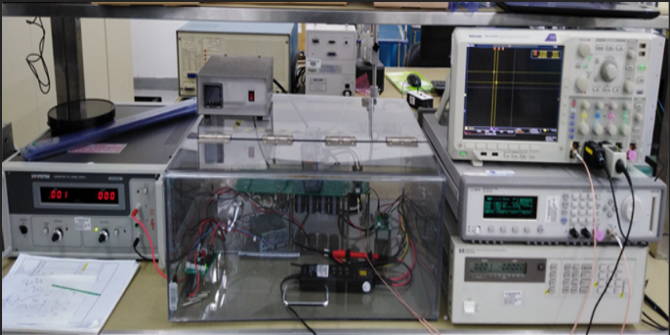
Fig. 1. AC Inductive Switching test set up.
Keywords—LabVIEW, AC Inductive Switching, Data Acquisition, Characterization, Programming, Median filter, Time Efficiency
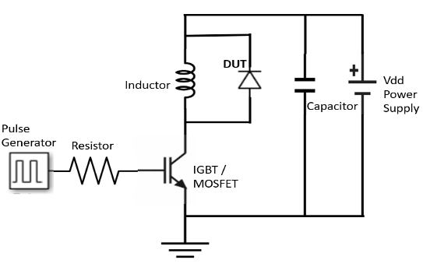
Fig. 2. Double pulse test circuit.

Introduction
Test setup for AC Inductive Switching test has been successfully released in 2019. Using the existing bench setup as shown in Figure 1, this was manually setup based on the test conditions. The technician will set the test conditions for Source Voltage (VCE), Source Current (ICE), Gate Voltage (VGE), Gate Resistor (RG), temperature and device under test. A switching test will be done and the oscilloscope will generate the waveform depending on the test condition setup. The technician will record the switching parameters for turn-on and turn-off test results manually by referring to the waveforms.
The switching test was done using the standard double pulse test consists of inductive load and a power supply as shown in Figure 2. The inductor re-creates circuit conditions and the power supply provides voltage to the inductor. An arbitrary function generator is used to generate output pulses that trigger the gate of the IGBT and thus turns it on to start the conduction of current.
To measure the switching parameters, the technician will zoom into the falling edge of the first pulse for turn off parameters and the rising edge of the second pulse for turn on parameters. Technicians follow the formula per datapoints for turn on and turn off, so it is quite a lot of work for the technician to manually zoom into each parameter and record the results.
To improve the characterization process, automated data acquisition was developed and implemented using the LabVIEW software. The application was internally developed to capture the full double pulse waveform data on the oscilloscope and an inductive switching test is carried out by measuring the waveform data through multiple formulas of searching points. This application will have a similar test condition setting as an input consist of VCE, ICE, VGE, RG, Temperature and DUT like the existing bench setup, the only difference is it will be automated data acquisition and the results will autosave in the specific folder.
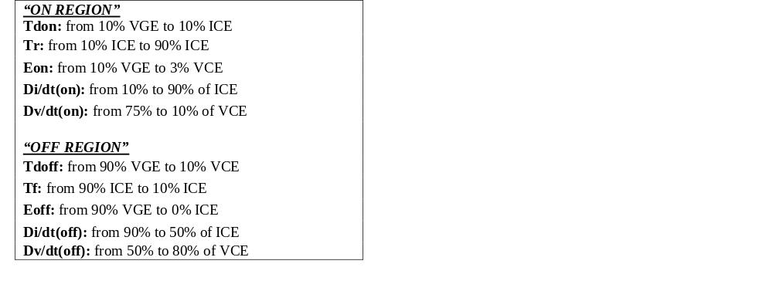

Fig. 5. The Formula for searching point.

Instrument Setup
Tektronix DPO 40548B oscilloscope is connected to computer PC via Device Port-to-USB wire for hardware communication as shown in Figure 3. The setup can be referred to in the instruction manual provided by Tektronix [1].
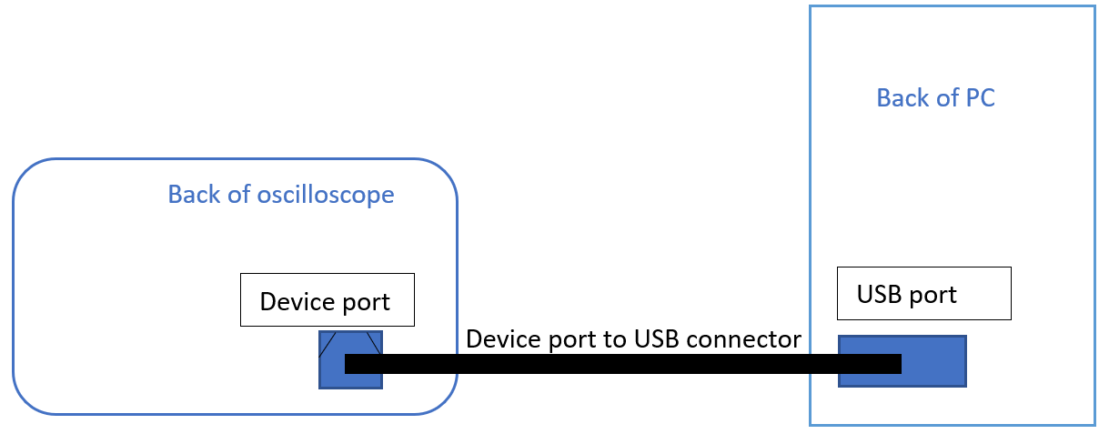
Fig. 3. Oscilloscope connected to PC.

Application process flow
The user needs to make sure that a full double pulse waveform fits the current oscilloscope screen by adjusting the zoom feature on the oscilloscope and pulse width through the pulse generator. As shown in Figure 4, the application will start by capturing 10,000 data points from the oscilloscope screen and export them into a comma-separated values (CSV) file format.
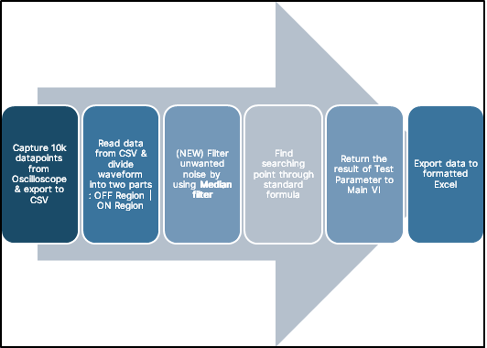
Fig. 4. Flow chart of the full application.

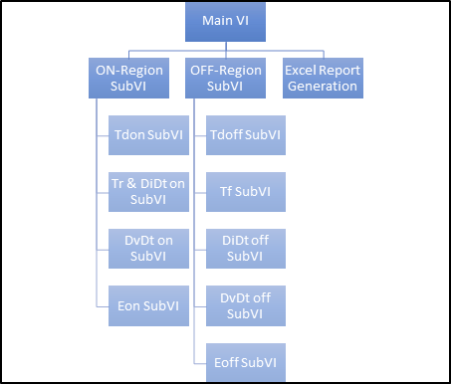
Fig. 6. Hierarchy of programming.
The CSV file data will then be used for imitating the original waveform into the waveform graph in the application. From this graph, the waveform will then be divided into two parts; “ON Region” and “OFF Region”.
In these two regions, 10 test parameters will be measured by placing specific searching points on the VCE, ICE & VGE waveforms. The searching points are standardized across all the devices using the formula shown in Figure 5.
In old manual acquisition, the occurrence of noise in source voltage and current would make the searching point vague. Hence, a Median filter is introduced for finding the accurate searching point. The differences in time and amplitude between the two searching points produce the result of the test parameter.
The results will then be returned to the main GUI for display. Users can check the results and decide on the next test condition. After the inductive switching test is carried out respective to its test condition, all the results will then be exported into a formatted Excel report automatically.

LabVIEW programming structure
LabVIEW software is known for its engineering solution of creating an application using the built-in libraries and open-source drivers to communicate with lab instruments [2]. The graphical programming code is in a form of wiring a built-in SubVI or classes in C++ [3]. To produce a LabVIEW application, the code is programmed in Block Diagram while the GUI (Graphic User Interface) is designed in the Front Panel.
The most important thing in LABVIEW coding is making a hierarchy structure. Figure 6 illustrates the design structure of LabVIEW programming. The parent-child relationship started from the Main VI as the “parent”. The main code and GUI for the application are designed in this Main VI. Under the Main VI, there will be three child classes or Sub VI named ON-Region SubVI, OFF-Region SubVI and Excel Report Generation.
In the Main VI, on the left side of the Front Panel, a cluster of controls are presented (Figure 7). These are the controls for finding the oscilloscope source connection and the controls for test conditions with project number and request number.
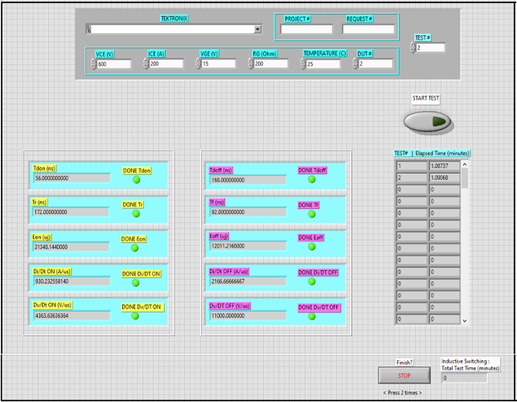
Fig. 7. Front Panel on the left side of the application.

This area will be the first one to be seen after the user run the executable file. There are also indicators for the result of each test parameter after the user presses the start button. The elapsed time indicator shows the time taken to complete the inductive switching test on that current test condition. After all the test conditions are completed, the user needs to press the stop button twice.
Following the stop button action, the total test time will be calculated, and the report file will be produced. On the right side of the Front Panel, a table (Figure 8), displays the complete inductive switching data that will be exported into an Excel report. This area contains all the results after running the Inductive AC Switching Test.
The pseudocode of Main VI can be referred to in Figure 9. This pseudocode translates the complicated visual wiring from the Main VI into more understandable workflow process for an easy read.
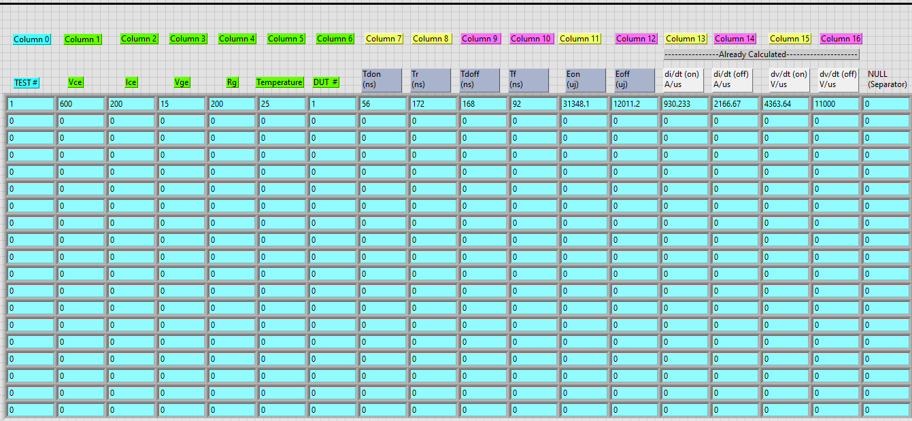
Fig. 8. Front Panel on the right side of the application.
For sub VI, the concept of coding the “ON Region test” and “OFF Region test” are similar. Therefore, the following explanation describes the code implementation in both region tests.
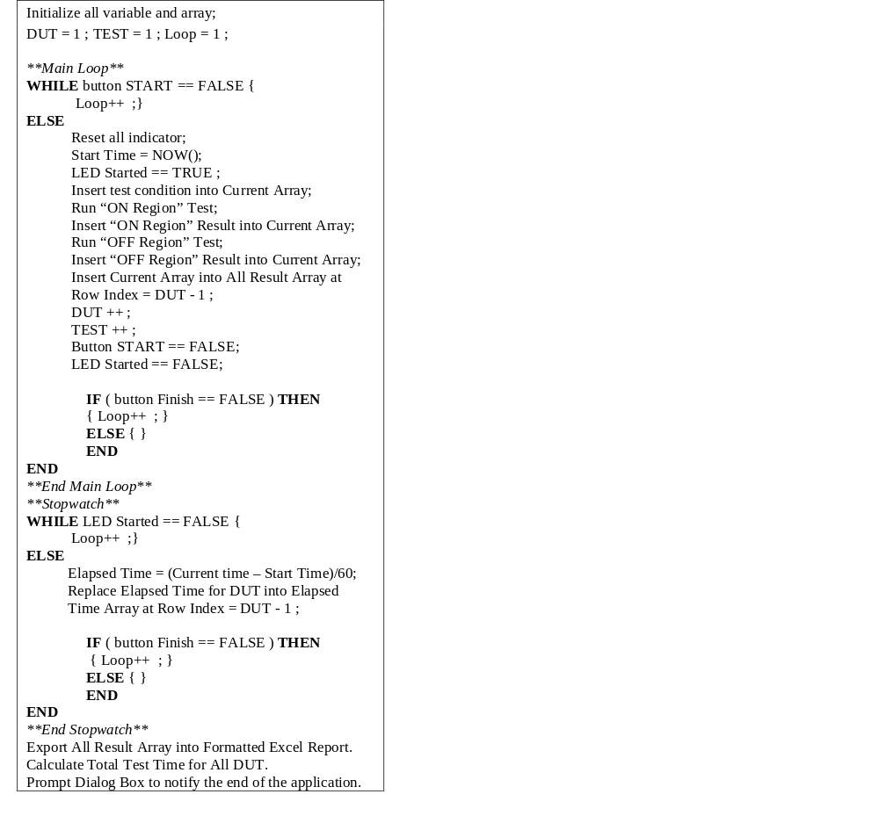

Fig. 9. Pseudocode of Block Diagram in Main VI.

The Front Panel consists of two waveform graphs. The first graph, located on the left side, is hidden from the user’s sight while the second graph, located on the right side, would be popped up and is visible every time the related test is run.
The first graph will read the CSV file of original double pulse waveform data exported from the oscilloscope. Then, from this waveform the ON Region and OFF Region can be determined by finding the intersection edges of multiple signals that are situated closer to the center of the Waveform Graph (Figure 10). The ON Region would be on the right side while the OFF Region would be on the left side.
As shown in Figure 11, the second graph contains a new waveform, which shows the real-time acquisition in retrieving the result of the test parameter from the original waveform in the first graph. This graph will show a quick change of scaling and cursor movement to visualize the steps of finding the searching point on the related signals according to the standardized formula.
Figure 11 shows the effectiveness of the Median filter. The magenta-colored wave is the original signal of VCE while the purple-colored plot is the median filtered VCE. This shows that the Median filter can de-noise the amplitude while retaining its phase value. The first step in producing the second waveform is by building a Median-filtered waveform through sorting data points value on the left side and right side of the current point and replacing its values with the median of the rank after the sorting. The rank is standardized to be a value of 25 after multiple studies on the amplitude response and phase response. The Median filter was chosen as the noise filter for its advantage of retaining the sharp edges of the original signal [4]. This is very important as all of the test parameters are characterized in nano seconds. The next step would be implementing the formula to calculate and find the searching point on the waveform using Basic Trigger Level VI. The last step before exporting the waveform image and leaving the region test Sub VI is to calculate the test parameter result using the amplitude and time data of both searching points.
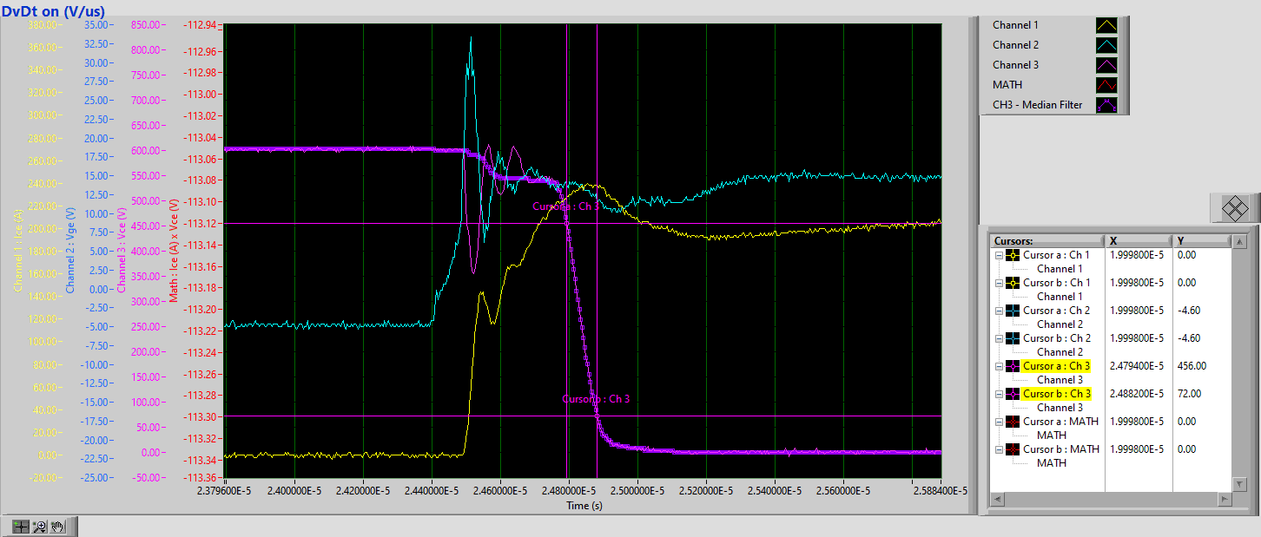
Fig. 11. The Second Graph: an example of the Median Filter applied on dv/dt ON test.

Potential Risk and Mitigation
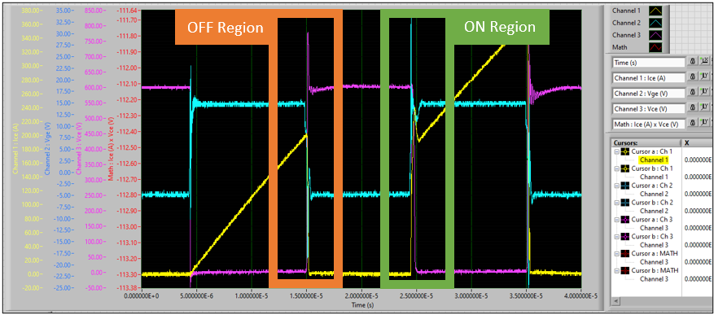
Fig. 10. The First Graph: ON Region and OFF Region from the original double pulse waveform.

Table 1. Potential Risk and its Mitigation.

Potential Risk | Mitigation
Accuracy of Data | Perform correlation on various devices with different current & voltage ratings.
Technicians insert test conditions wrongly | Follow-up closely & training
Software Memory Crash | Backup Software into another PC (Readily backed-up in engineer’s laptop)
Change of Oscilloscope model | Change the LabVIEW driver for the model (“If needed”)
Some DUTs might have unacceptable value | Discuss with Product Engineer for device issue and check the device characterization. (Internal Communication)
There might be unexpected errors, problem, or risk due to the software or human errors or a sudden change of environment in the lab. Therefore, a workaround has been determined to solve these problem as shown in Table 1. Correlation of various devices with different current and voltage ratings were done. All our correlation tests passed with < 10%. The training for the technicians is also completed, and backup software is secured in another PC in case of software crash. As for the change of oscilloscope model, the engineers will need to take note if the model will be changed in the future. And if some of the DUTs have unacceptable values, the reliability engineers need to discuss this with the Product Engineering team to investigate if it is a device issue. This also needs to be confirmed with the device characterization team. In our work all these potential risks and mitigations were completed and documented.

Qualification Results
Three identical products were used for the qualification purposes as shown below in Table 2 ranging from the low, mid and high current ratings. These products were used for the correlation; comparing the manual data acquisition versus the new application program.

Table 2. Three identical products with switching test conditions.

Device: IGBT | Condition | Rating Category
1st Device | VCE = 400, ICE = 175, VGE = 15 | High
2nd Device | VCE = 400, ICE = 50, VGE = 15 | Mid
3rd Device | VCE = 400, ICE = 30, VGE = 15 | Low
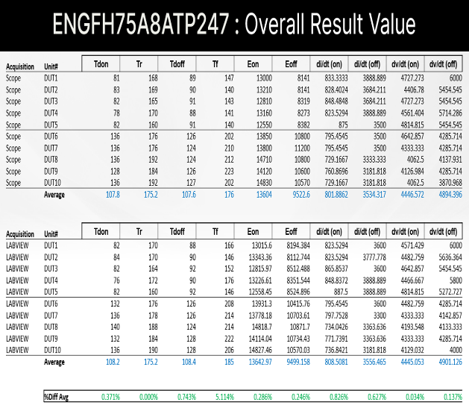
Fig. 12. Device rated current = 175A, manual data versus automated data acquisition correlation results.

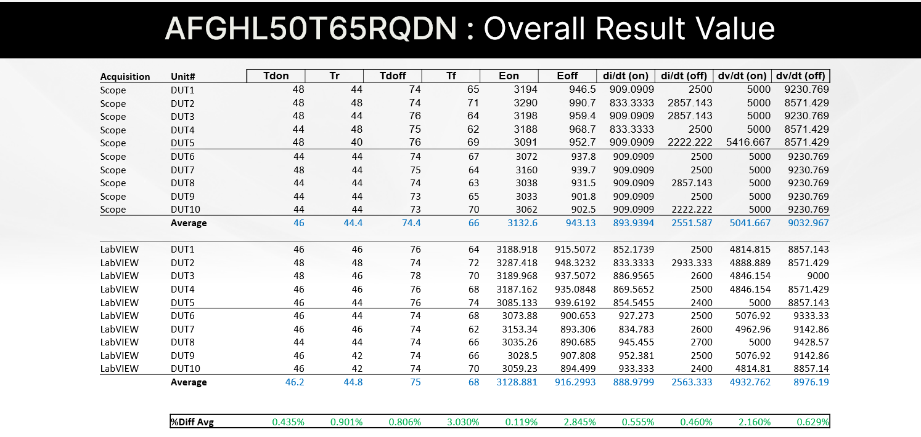
Fig. 13. Device rated current = 50A, manual data versus automated data acquisition correlation results.

Based on the correlation results, the highest-rated current ICE = 175A correlation results shows < 10% of the percent average differences between the scope versus the LabVIEW new applications (Figure 12). The highest percentage difference is Tf test parameters but still within the < 10%. The rest of the parameters are at < 1% difference in average.
1st Device
While for the ICE = 50A, the percentage average difference is < 5% between the scope and LabVIEW data acquisition as shown in Figure 13. And lastly, the ICE = 30A also shows overall percentage differences between the scope and LabVIEW at < 5% as shown in Figure 14. In summary all the three devices with different current rating (low, mid and high) passed the correlation criteria of < 10%.
The manual data acquisition requires 15 minutes = 900 seconds for all the steps in data acquisition per DUT while the LabVIEW automated data acquisition only takes 45 seconds (less than 1 minute) to have all the turn on and turn off parameters results available.
Safe Launch was also completed using the 2nd Device. The turn-on and turn-off parameters were taken following the datasheet condition with the use of different units. Based on the comparison of the measured typical values, the results are close to datasheet specifically for Turn off parameters and some of Turn on parameters as shown in Figure 15. It is expected to have significant difference between safe launch result and datasheet value due to several reasons. The reasons are, firstly, safe launch requires a median value of 10 units while datasheet test only requires a median value of 5 units.
2nd Device
3rd Device
The safe launch typical measured values tally with the safe launch curves as shown in Figure 16 for Turn on, Figure 17 for Turn off and Figure 18 for Switching losses. Some differences are expected between the data wherein Safe Launch have slightly higher in Tdon, tr and lower in Eon is values because we used different set of samples and it is expected to have different characteristics in some of the parameters.
Overall, the safe launch curves have the same behavior as the datasheet and are comparable.
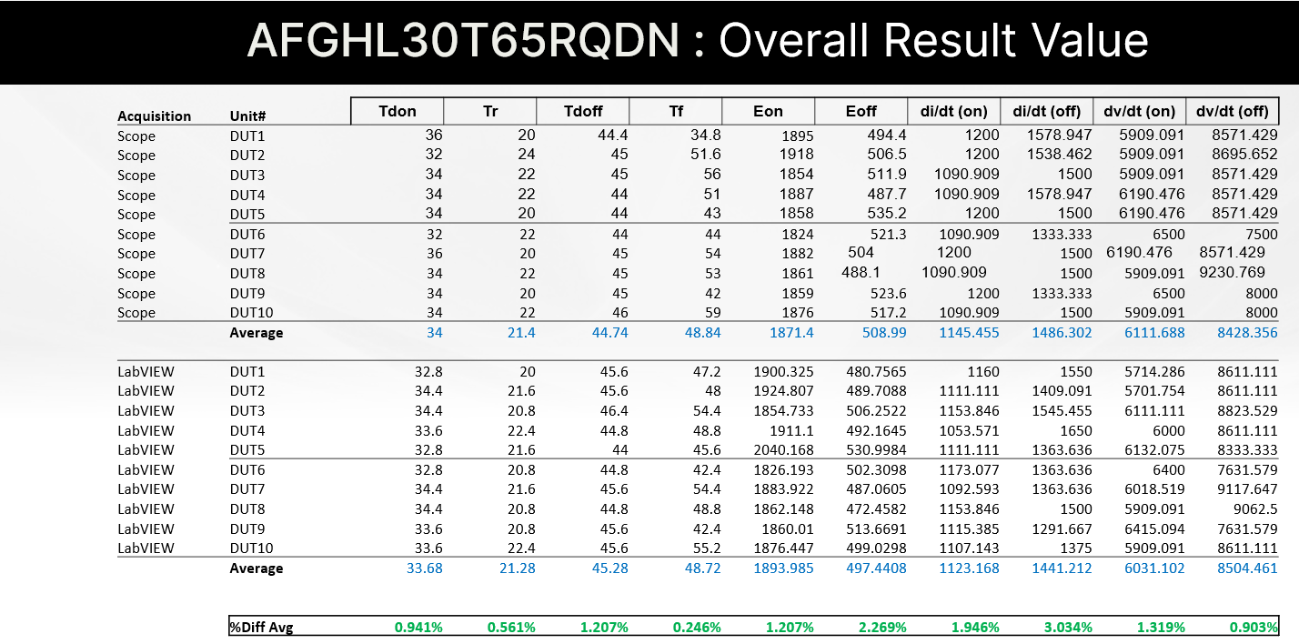
Fig. 14. Device rated current = 30A, manual data versus automated data acquisition correlation results.

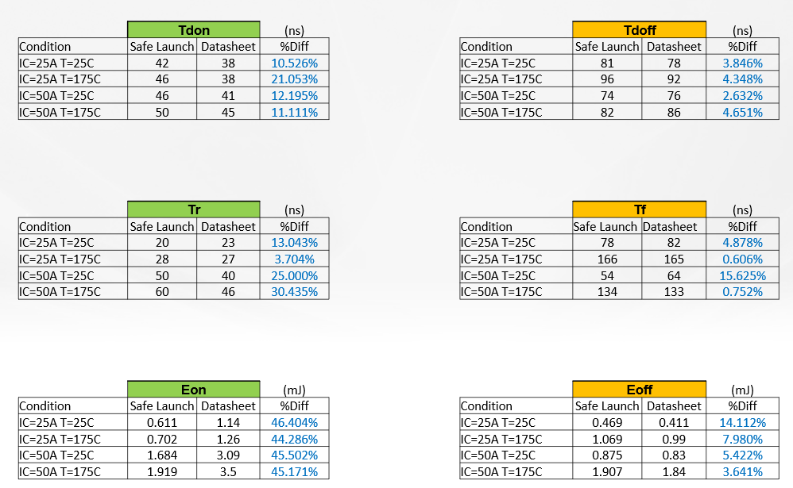
Fig. 15. Safe Launch and Datasheet comparison.

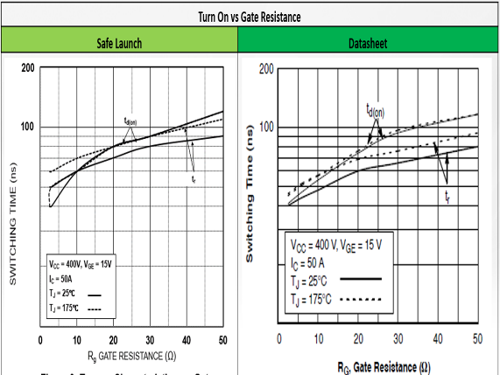

Fig. 16. Turn on versus Gate Resistance - Safe Launch and Datasheet comparison.

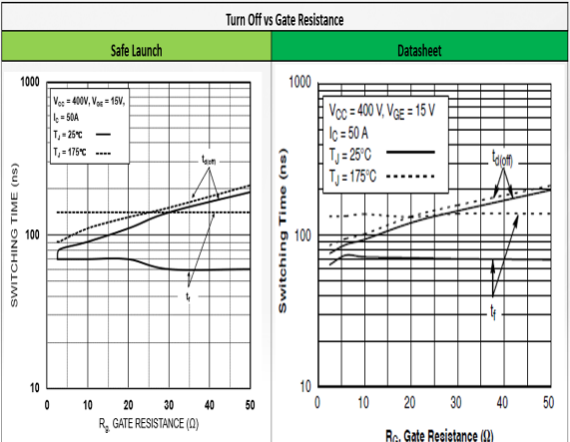
Fig. 17. Turn off versus Gate Resistance - Safe Launch and Datasheet comparison.

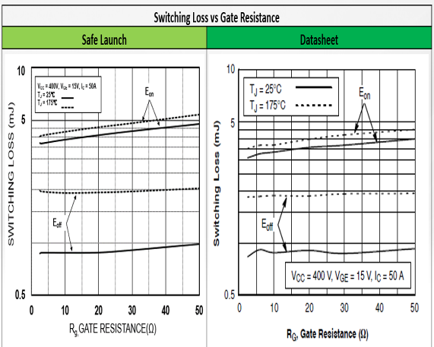
Fig. 18. Switching Loss versus Gate Resistance - Safe Launch and Datasheet comparison.

Table 3. The Time Taken for each devices using LabVIEW Acquisition vs Manual Acquisition
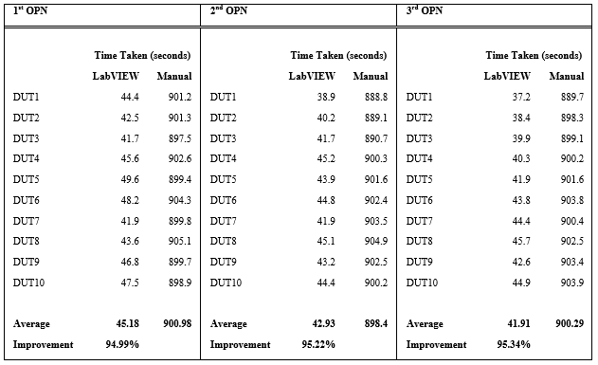
Another qualification test is by comparing the time taken for LabVIEW acquisition with the manual acquisition. Based on the time taken value in Table 3, the LabVIEW application program improved the time taken for the data acquisition by 95%.

Conclusion
In conclusion, the new LabVIEW automated data acquisition developed for Inductive AC Switching is capable of meeting the qualification correlation criterion of < 10% and the safe launch typical measurement and curves are comparable to the datasheet. This new automated application reduces the data acquisition time by 95% from 900 seconds to 45 seconds and improves the data accuracy. This breakthrough will pave the way for our reliability labs to proceed with the implementation of this new application not only for the Inductive AC Switching test for discrete devices but also for other module products. Moreover, the LabVIEW programming method is also applicable to other characterization tests such as TRR (Time Recovery Rate) and Gate Charge.

Acknowledgment
A huge gratitude to the head of department for CZ Lab and APG HV NPD for allowing this collaboration project. Big appreciation to the technician of CZ Lab for assisting the qualification process.

References
[1]Download.tek.com, 2003. [Online]. Available: https://download.tek.com/manual/071281002web.pdf. [Accessed: 12- May- 2022]
[2]"Product Documentation - NI", Ni.com, 2020. [Online]. Available: https://www.ni.com/docs/en-US/bundle/labview-2021/page/lvmeasconcepts/using_lv_to_control_inst.html. [Accessed: 31- May- 2022]
[3]"Product Documentation - NI", Ni.com, 2022. [Online]. Available: https://www.ni.com/docs/en-US/bundle/labview-2021/page/lvconcepts/front_oolv.html. [Accessed: 31- May- 2022]
[4]D. Stone, "Application of median filtering to noisy data", Canadian Journal of Chemistry, vol. 73, no. 10, pp. 1573-1581, 1995.

